

EXOR

Maintenance Manager Release Notes

Document Version History
Version | Owner | Source | Date | Description
1.0 | Chris Baugh |  | 16-Oct-2019 | Initial Draft
For review: |  |  |  | For approval:

Table of Contents
1 About this Document 3
1. Authors 3
2. Document Summary 3
3. Reference documents 3
1.3.1 4.7.0.0 Fix Documentation 3
4. Distribution 4
2 Introduction 5
3 Enhancements and Changes at 4.8.0.0 6
1.1 Fix 3 Enhancements 6
1.1.1 New Product/User Option DEFDOCCAT 6
1.2 Fix 5 Enhancements 7
1.2.1 Work Order Automation Rules (MAI3818) Modification 7
1.3 Fix 7 Enhancements 7
1.3.1 XSP Validation 7
1.3.2 Provide Asset Search from Works Order Form (MAI3800) 7
1.4 Fix 8 Enhancements 8
1.4.1 Changes to apply Network Group Resize operations to data in MAI 8
1.4.2 Changes to how Network Element Reversal is applied to data in MAI 8
1.5 Fix 15 Enhancements 8
1.5.1 Allow for retrospective Inspections on a Work Order 8
1.6 Fix 16 Enhancements 8
1.6.1 Standard Rate Itemisation on Contracts 8
1.7 Fix 17 Enhancements 8
1.7.1 Addition of Associated Documents to CIM Works Order File 8
1.8 Fix 19 Enhancements 9
1.8.1 AssetWise CONNECT Document Manager Product Options 9
1.9 Fix 20 Enhancements 9
1.9.1 AssetWise CONNECT Document Manager Photo Upload Product Options 9
1.10 Fix 21 Enhancements 9
1.10.1 eB Defect photo processing 9
2 Known Problems at 4.8.0.0 10

About this Document

Authors
- Chris Baugh

Document Summary
This document provides a description of the changes in this release and information about how these changes may impact on an installation.

Reference documents

4.7.0.0 Fix Documentation
As Release 4.8.0.0 of Maintenance Manager is a roll-up of all 4.7.0.0 fixes, up to and including fix 23, all associated fix documentation is included in this release for reference.
Fix No. | Associated Documents | Fix Details | Description
1 | exmai04070003en_updt1.pdf | Fix 01 (Build 3) - Module Re-Versioning | Bundled in with base 4700
2 | exmai04070004en_updt2.pdf | Fix 02 (Build 4) - Assorted escalations
3 | readme_exmai04070001en_updt3 | Fix 03 (Build 1) - Inspection Loader | See section 1.1 for Enhancements included in this fix
5 | readme_exmai04070002en_updt5.pdf | Fix 05 (Build 2) - WO Automation | See section 1.2 for Enhancements included in this fix
6 | readme_exmai04070001en_updt6.pdf | Fix 06 (Build 1) - Assorted escalations
7 | readme_exmai04070001en_updt7.pdf | Fix 07 (Build 1) - XSP Validation | See section 1.3 for Enhancements included in this fix
8 | readme_exmai04070001en_updt8.pdf | Fix 8 (Build 1) - Network Edits | See section 1.4 for Enhancements included in this fix
9 | readme_exmai04070001en_updt9.pdf | Fix 9 (Build 1) - Assorted escalations
10 | readme_exmai04070002en_updt10.pdf | Fix 10 (Build 2) - Assorted escalations
11 | readme_exmai04070001en_updt11.pdf | Fix 11 (Build 1) - Alert Manager
12 | readme_exmai04070002en_updt12.pdf | Fix 12 (Build 2) - Budgets
13 | readme_exmai04070001en_updt13.pdf | Fix 13 (Build 1) - Payment Approval
14 | readme_exmai04070002en_updt14.pdf | Fix 14 (Build 2) - Assorted escalations
15 | readme_exmai04070004en_updt15.pdf | Fix 15 (Build 4) - Assorted escalations | See section 1.5 for Enhancements included in this fix
16 | readme_exmai04070004en_updt16.pdf | Fix 16 (Build 5) - Contract Breakdown | See section 1.6 for Enhancements included in this fix
17 | readme_exmai04070003en_updt17.pdf | Fix 17 (Build 4)- CIM Associated Docs | See section 1.7 for Enhancements included in this fix
19 | readme_exmai04070001en_updt19.pdf | Fix 19 (Build 1) -  AssetWise CONNECT Document Manager | See section 1.8 for Enhancements included in this fix
20 | readme_exmai04070001en_updt20.pdf | Fix 20 (Build 1) - AssetWise CONNECT Document Manager | See section 1.9 for Enhancements included in this fix
21 | readme_exmai04070001en_updt21.pdf | Fix 21 (Build 1) - AssetWise CONNECT Document Manager | See section 1.10 for Enhancements included in this fix
22 | readme_exmai04070001en_updt22.pdf | Fix 22 (Build 1) - Inspection Loader
23 | readme_exmai04070002en_updt23.pdf | Fix 23 (Build 2) - Zero Cost WOs

Distribution
Bentley/Customers, Partners and Colleagues

Introduction
This document defines the key changes made to the Maintenance Manager product at release .
Unlike the “Maintenance Manager Installation/Upgrade Guide”, this document is specifically targeted at the Maintenance Manager end user. Therefore, if the recipient of this document is an IT person please ensure that it is forwarded on to the relevant end user(s).
It is not intended to be a full system description but a guide to indicate what changes have been made, why they have been made and the potential failings if this upgrade is not applied.
This release is available as an upgrade from release 4.7.0.0. of the Maintenance Manager product.
Please note that any data shown in example screenshots does not represent any Customer’s live data; it is test data set up by Exor.
After reading through this document, should you have any need for training or consultancy then please contact your EXOR/Bentley account manager. If these changes are considered important for your current release and this is incompatible with this patch release, then please contact support.
This release is, in the main a roll-up of all fixes applied to the 4.7.0.0 Maintenance Manager release, up to and including Fix 23.

Enhancements and Changes at 4.8.0.0
The following is an overview of Enhancements & Changes included in the specified 4.7.0.0 Fix. For more detail on any of the changes please refer to the associated fix documentation.

Fix 3 Enhancements

New Product/User Option DEFDOCCAT
This will be used as a default when loading a file via the Maintenance Manager Inspection Loader when no value is assigned in the loader file
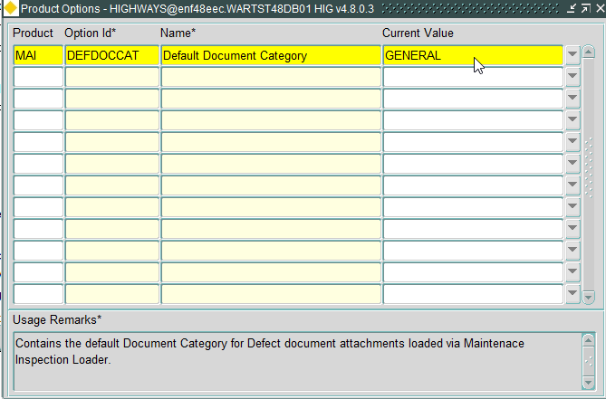
Note: When modifying the Product Option value, a refresh is required to ensure the Product Option change has been applied

Fix 5 Enhancements

Work Order Automation Rules (MAI3818) Modification
When identifying Repairs to add to a Work Order, Work Order Automation rules were placing multiple repairs on separate Work Orders, even though Multiple Repairs should appear on the same Work Order. This happened when the repair due dates on each of the repairs fell between different financial years.
The Work Order Automation Rules form (MAI3818) has been modified to allow for either the Repair Due Date (Default) or Inspection Date to be used to identify the repairs to add to a Work Order, by use of a new radio button:
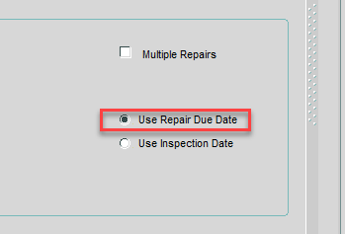

Fix 7 Enhancements

XSP Validation
Prior to applying this fix the integrity of Defect XSPs could be an issue when working with maintenance sections that are groups of datum elements as a result Defect XSPs may be flagged as invalid should any validation be applied.

Modifications have been made to a number of forms that will allow them to work correctly alongside the changes made in Network Manager 4.7.0.x fix 7. Please see the Network Manager 4.8.0.x release notes, along with the associated MAI fix documentation for a detailed explanation of these changes.
Enhancements have been made to the following forms:
- Work Orders (MAI3800)
- Defects (MAI3806)
- Inspections (MAI3808)

Provide Asset Search from Works Order Form (MAI3800)
Works Orders form (MAI3800) – The “Asset Query” button in the Defect Selection filter has been changed to call the exor Locator form to perform an asset search in line with other similar buttons in the product.

Fix 8 Enhancements

Changes to apply Network Group Resize operations to data in MAI
The MAI Reverse functionality is called when a network element is reversed. In order to support Hierarchical Networks this functionality has been extended to reverse the chainages recorded against Inspections, Defects, Work Order Lines and Frequencies when the Maintenance Sections are groups of Datum Elements.

Changes to how Network Element Reversal is applied to data in MAI
Functionality has also been added to MAI to apply a recalibration of Inspections, Defects, Work Order Lines and Local Section Frequencies when a Hierachical Network is in use and a Resize operation is performed on a Maintanence Section (Group of Datum Elements).

Fix 15 Enhancements

Allow for retrospective Inspections on a Work Order
Inspected Date Modifications have been made to allow for Defects to be assigned to a work order if the Defect inspected date is later than the date raised on the work order.

Fix 16 Enhancements

Standard Rate Itemisation on Contracts
An enhancement has been made to Contracts Form (MAI3880) to allow for Standard Item Rates to be broken down into an itemised list of values (Up to 10 values can be defined). The Standard Item Rate value will be the summation of each of the breakdown values defined.
A checkbox has been added to the initial Contracts screen to specify whether the Standard Item Rates will be broken down for a Contract, or if the Rate will be defined by a single value, as currently
If the breakdown checkbox has been selected for a contract, a new Tab Page will become available displaying the breakdown values and allowing for the Import and Export of Standard Items.
See the associated fix documentation for details on this enhancement.

Fix 17 Enhancements

Addition of Associated Documents to CIM Works Order File
The current CIM interface interfaces between Highways by Exor, external contractor systems and corporate financial systems.
This interface operates by the use of ASCII comma separated files, which are generated by Highways by Exor and the external systems involved.
The enhancement is to add the associated document details to the Works Order File

Fix 19 Enhancements

AssetWise CONNECT Document Manager Product Options
This patch includes Exor changes for AssetWise CONNECT Document Manager. 2 new product options have been introduced to integrate the AssetWise CONNECT Document Manager with Exor.
- DEFPHOTTEM - Set the eB Document’s Template ID of the BEFORE PHOTO class. This is required for the inspection loader batch to upload photographs for the defects.
- COMMTEMPLA - Set the eB Document’s Template ID of the COMMENT class. This is required for the inspection loader batch to upload comments for the defects.

Fix 20 Enhancements

AssetWise CONNECT Document Manager Photo Upload Product Options
eB’s photo upload file is created in CSV format in the directory MAI_INSP_DIRECTORY for each defect that gets processed through the inspection loader. This file should be converted in xlsx to allow upload into eB.
Two product options have been introduced, which will be used as part of this process:
- DEFPHOTFSM - If set to N files will be loaded as one document per file if set to Y all files will be loaded under single document, max 20 files.
- DEFPHOTLM - Value in this product option will be used as prefix for the document title.

Fix 21 Enhancements

eB Defect photo processing
This patch creates eB bulk loader CSV files in the AREA folder setup on the server and triggers the scheduler command to convert the CSV file to XLSX.

Known Problems at 4.8.0.0
None.

